**Name: Maria Arshad (BSCS)**

2:

3:

4:

5:

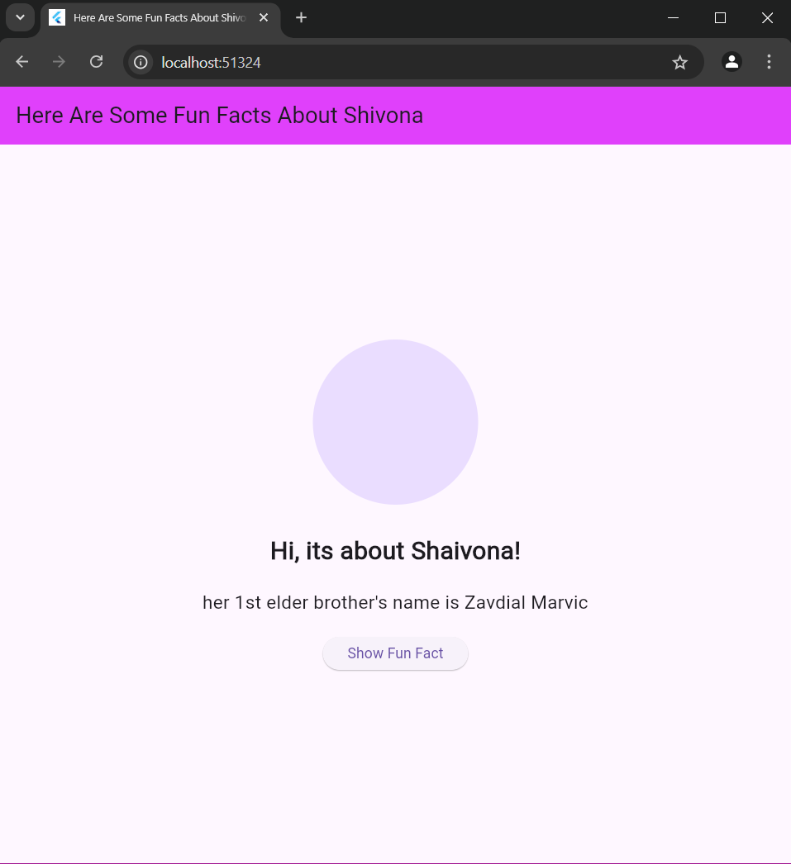

6:

